Databases
Exercises
Exercise 1
Configure your environment so you can use the AWS CLI. When the CLI is configured run the following command:
$ wget https://2tin-cloudessentials-resources.github.io/cloud-essentials-labs/debuglabs/5_1.yml -outFile 5_1.yml
$ aws cloudformation deploy --template-file ./5_1.yml --stack-name ch5ex1
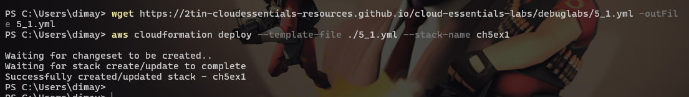

This will set up a pgadmin4 environment which you will be tasked to use in this exercise.
Scenario
In this exercise you will set up and configure a postgreSQL database in the cloud, using the RDS AWS service and configure this to work with an application.
Task 1: Create an RDS postgreSQL database
In the AWS Console, go to the RDS section and create a new PostgreSQL database.
- Use a "Standard Create" NOT "Easy Create"
- For this exercise, use the "Free Tier" template
- Pick a root password for the database and write it down!
- Make sure it can connect to EC2 instances, especially the one in the "Labo5DebugVPC"
- Once created write down the hostname to use later.
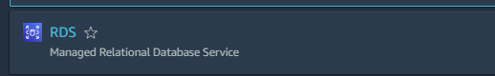
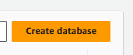
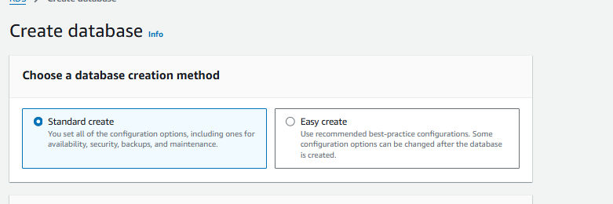
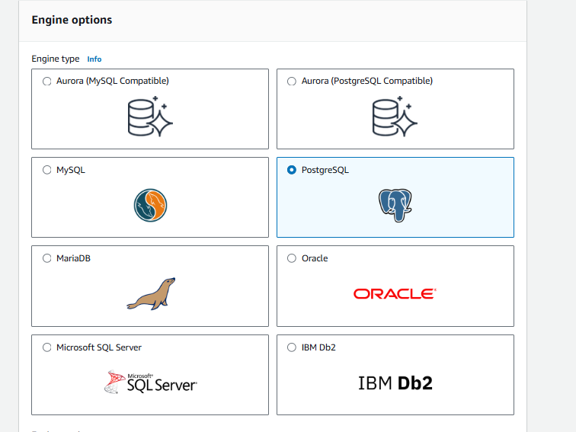
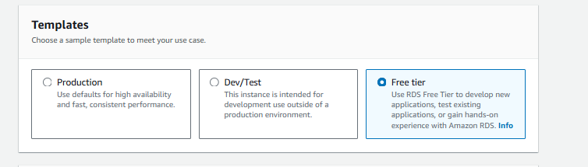
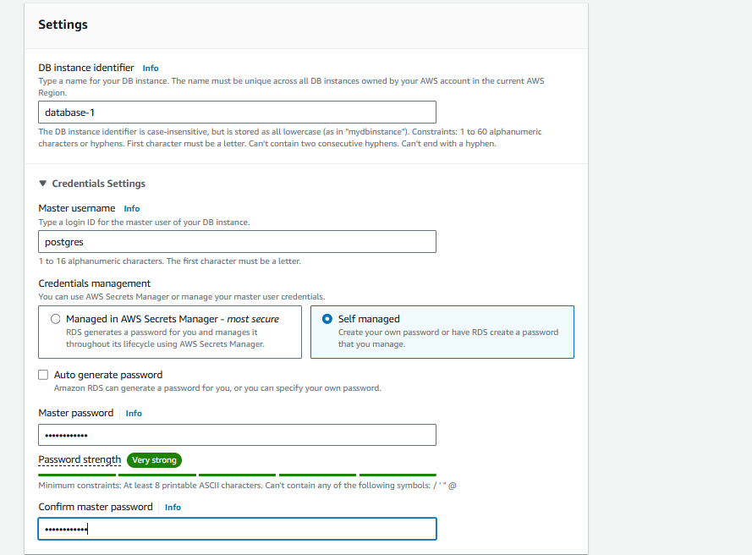
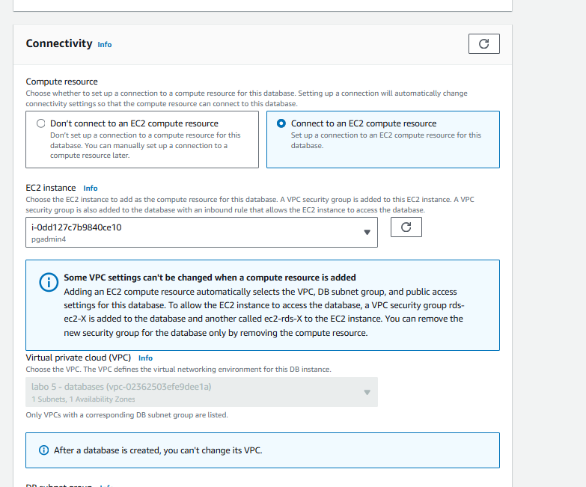
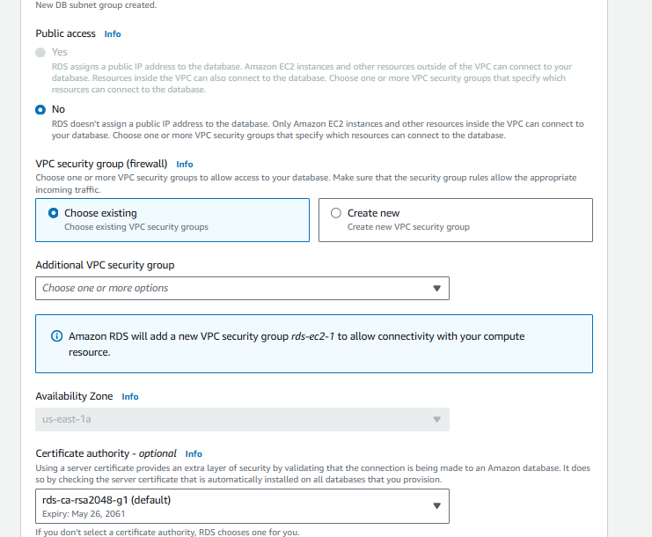
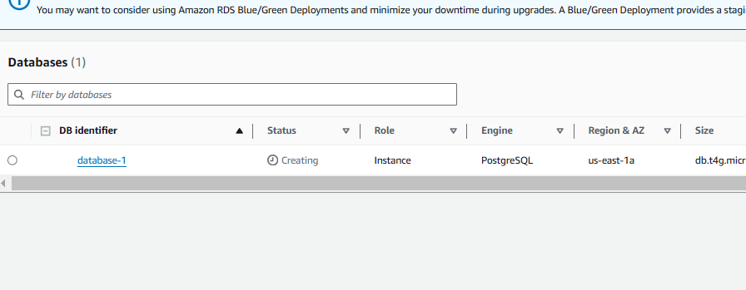
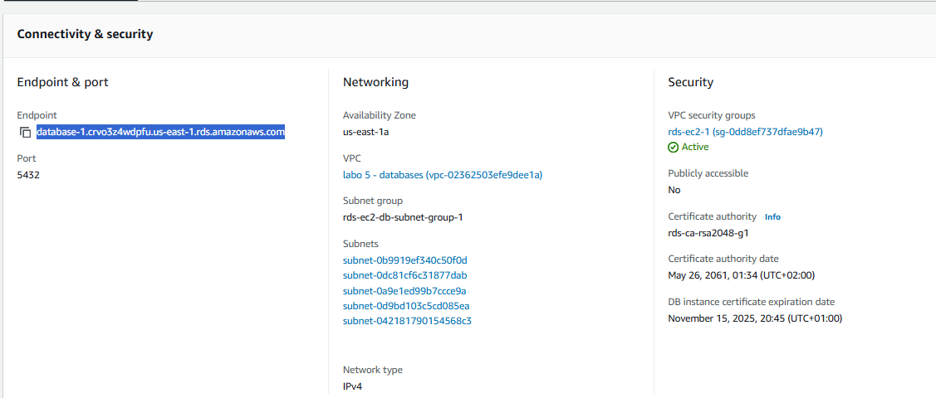
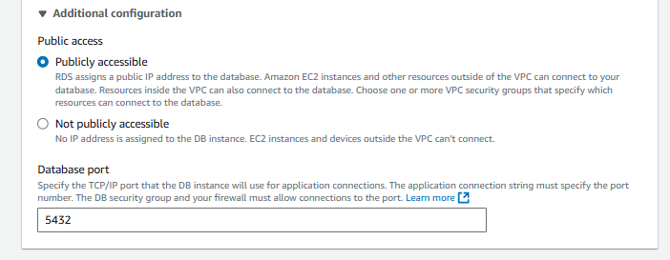
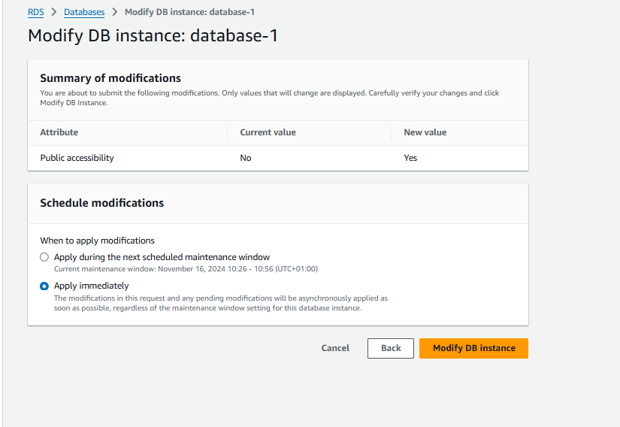
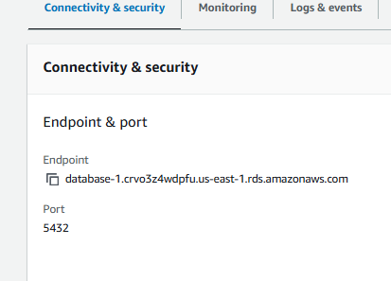

Task 2: Create a db connection in pgadmin4
- Lookup the public IP of the EC2 in the Labo5DebugVPC.
- Open the IP in your browser
- log in to the pgadmin4 app with following credentials:
User email: student@pxl.be
Password: SuperSecret
- "add new server" and use the hostname, login&password you write down earlier for the database.
Congratulations you've created a cloudhosted/managed database.
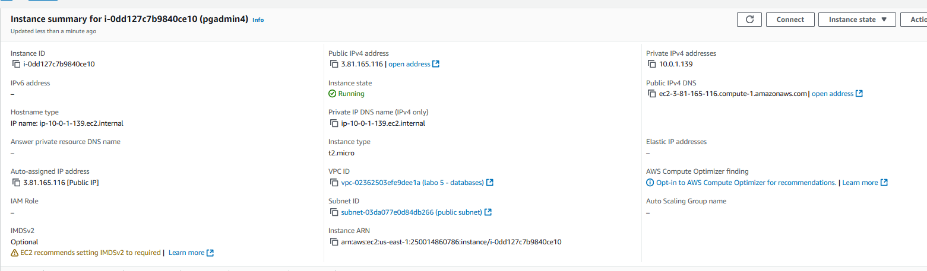
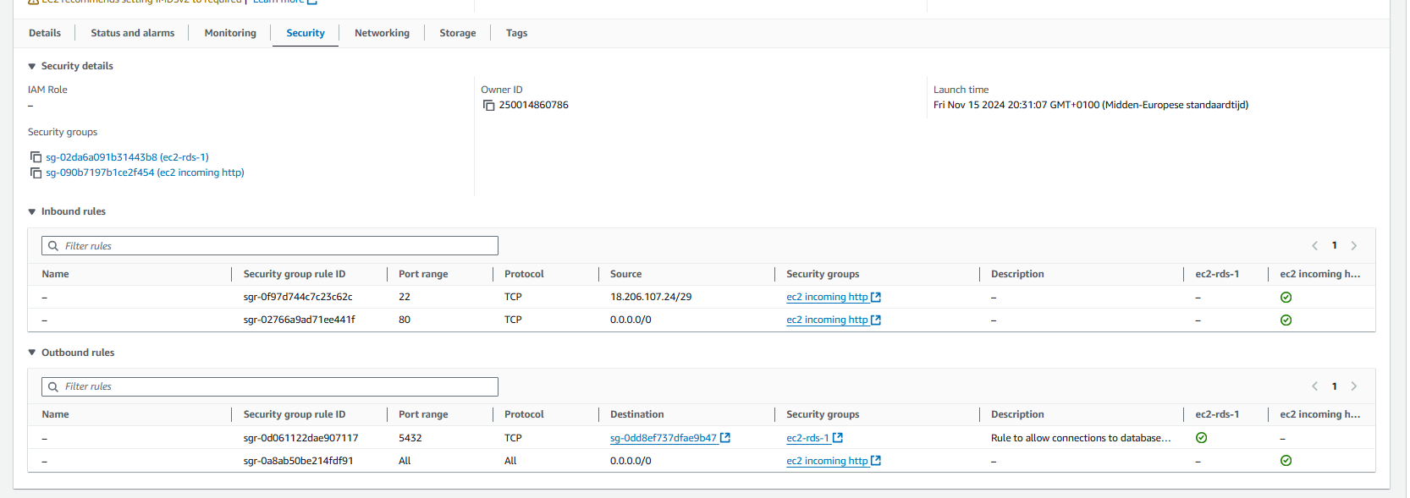
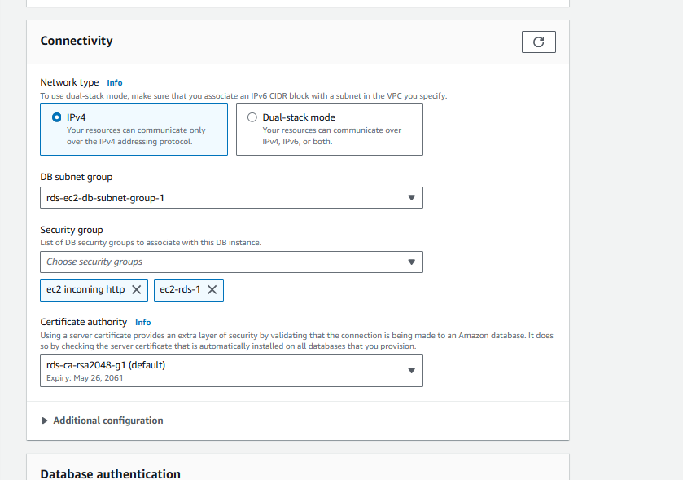
Modify instance

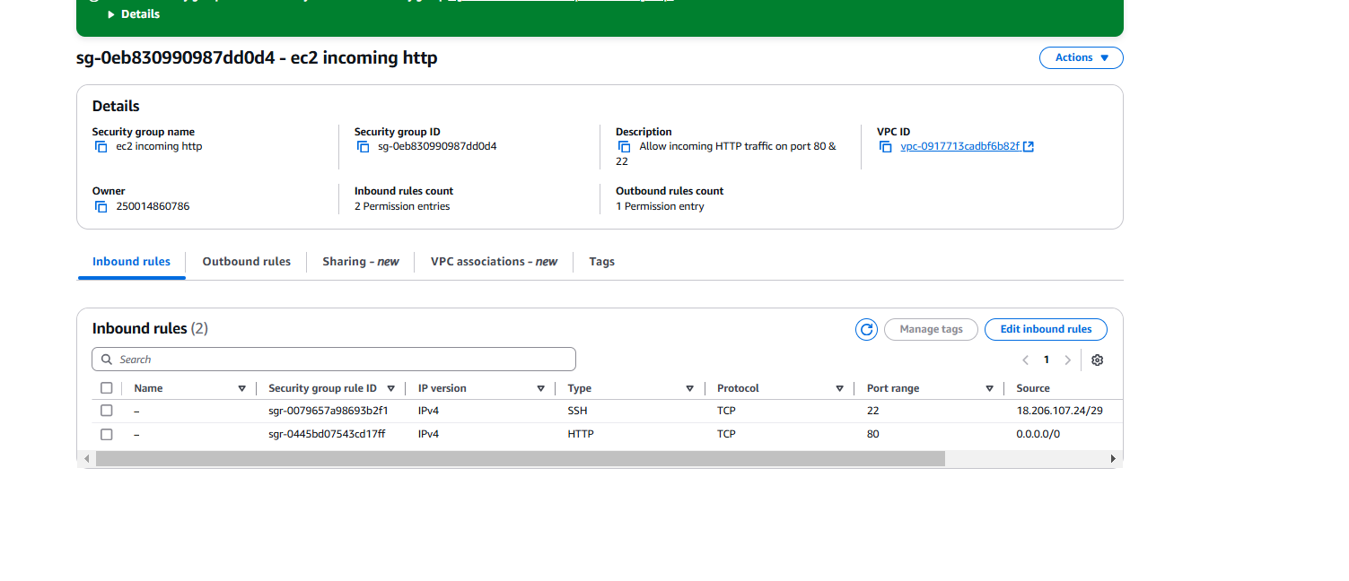
HTTP bij instance instellen
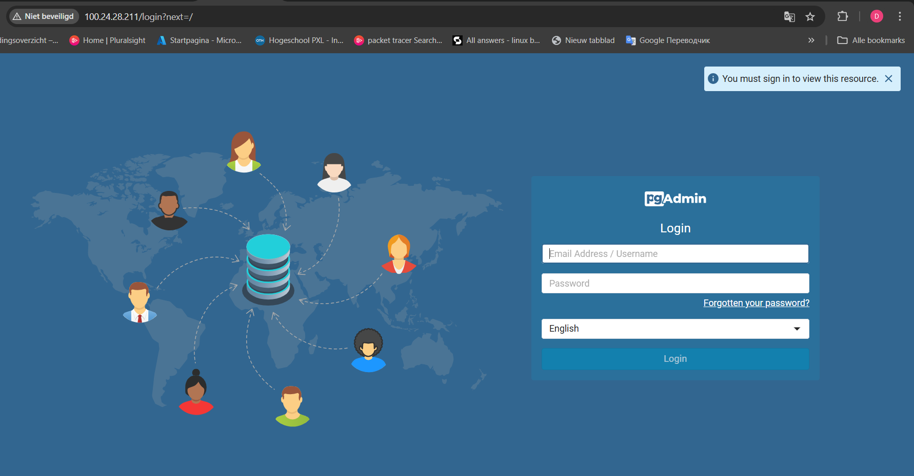
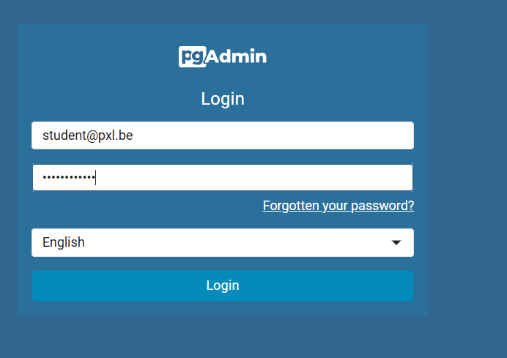
student@pxl.be
SuperSecret
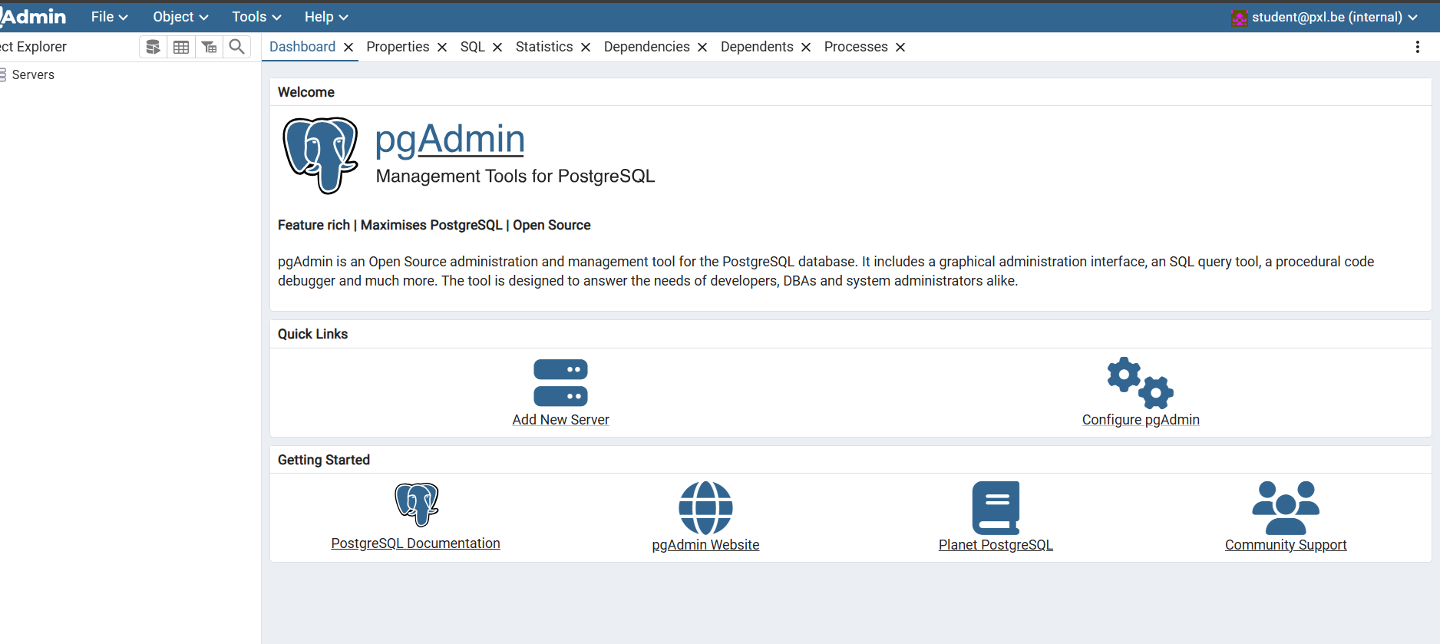
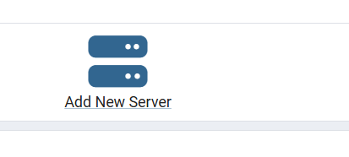
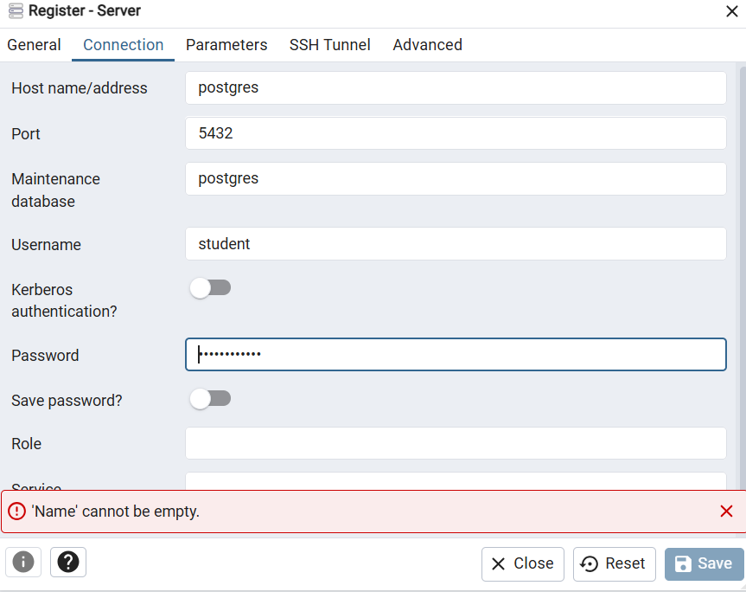
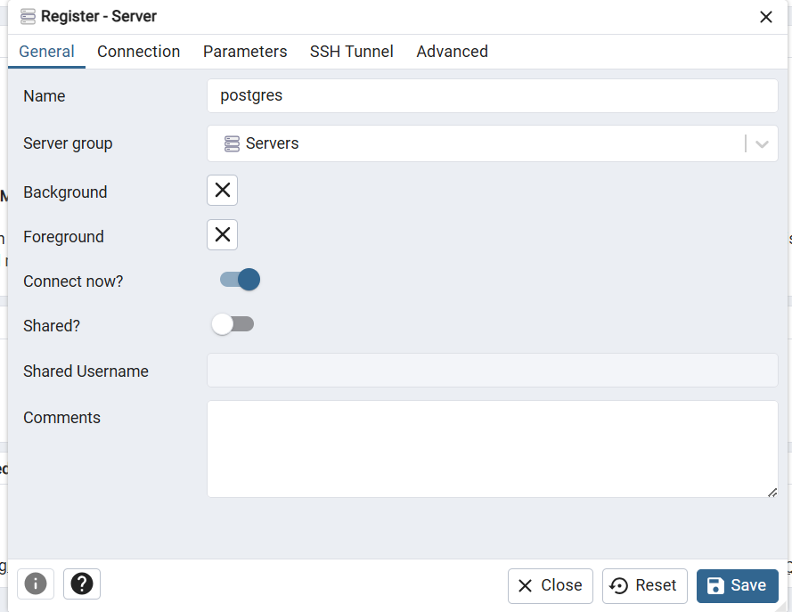

Finishing up
Don't forget to delete the RDS database you created before closing the lab environment!
When you are done you can run the command below to destroy resources used by this exercise:
aws cloudformation delete-stack --stack-name ch5ex1

